

Python and Deep Learning

Lab Assignment:1

-Rakesh Reddy Pallepati

-16231311

Contents:

1. Author

2. Objective

3. Features

4. Configuration

5. Input/output Screenshots

6. Implementation & Code Snippet

7. Deployment

8. Limitations

9. Reference

**Author:** Rakesh Reddy Pallepati

**Objective-**

To implement the following programs using python predefined functions like

1.Lists

2.Tuples,

3.Iterative loops

4.Functions

5.Conditional Statements

**Features:**

* These programs are developed using the basic functionalities
* The programs will give the required outputs according to our requirements.
* These Can also be implemented in the real time applications if needed.

**Input & Output Screenshots:**

**1.Input:**

We need to give the ideal password which need to have the upper, lower case characters, numbers and Special characters with min length of 6 characters and max length of 16 characters.



1.Output:

It need to verify all the above requirements.

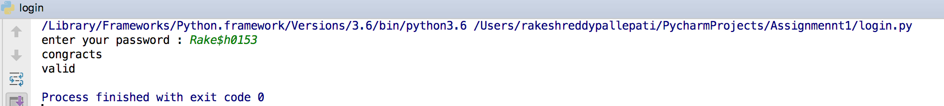

2.Input :

We need to give any sentence as input

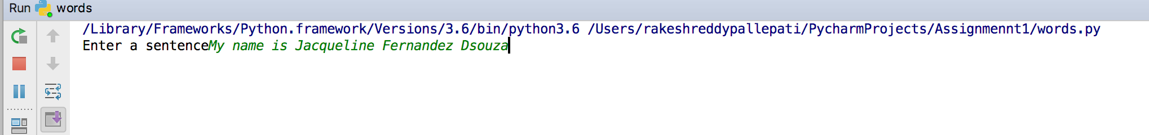

Output:

It need to give the middle word from the given sentence, it need to give the longest word from the sentence and finally we need to reverse each and every word in the sentence

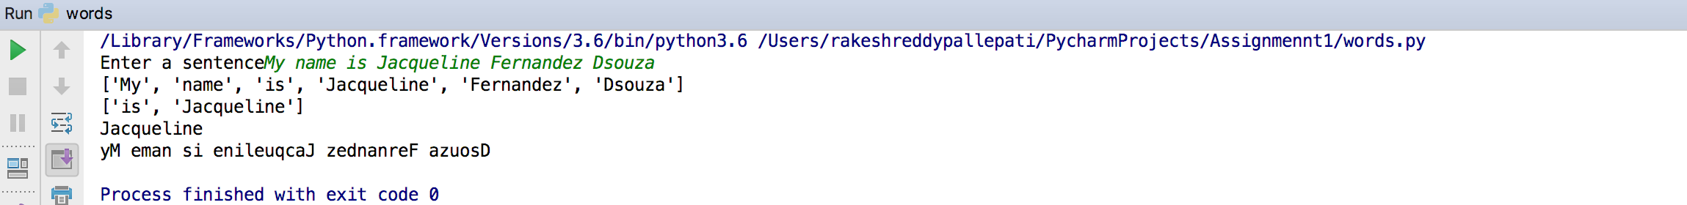

3.Input & Output:

We need to give the sample list which need to have the numbers and the program need to find the triplets from the list which should have the sum equal to zero

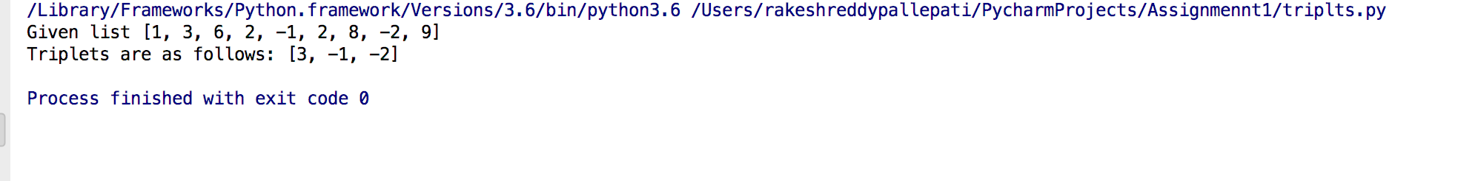

4.Input&Output:

Here we will have the students from two different classes and we need to categorize them as the common students in both subjects and the other students as follows:

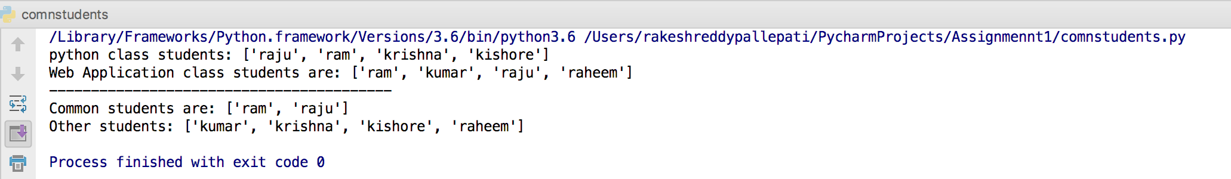

Implementation:

1. Login Password:

Password is checked using the multiple conditional loops and used the general functions used for strings.

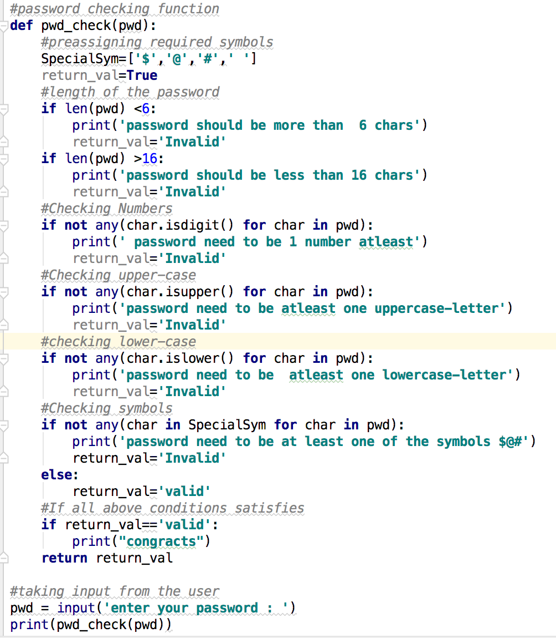

2.Sentence related Queries:

I have used the regular expressions to split the sentence, sorting the list, join function is used for reversing the sentence

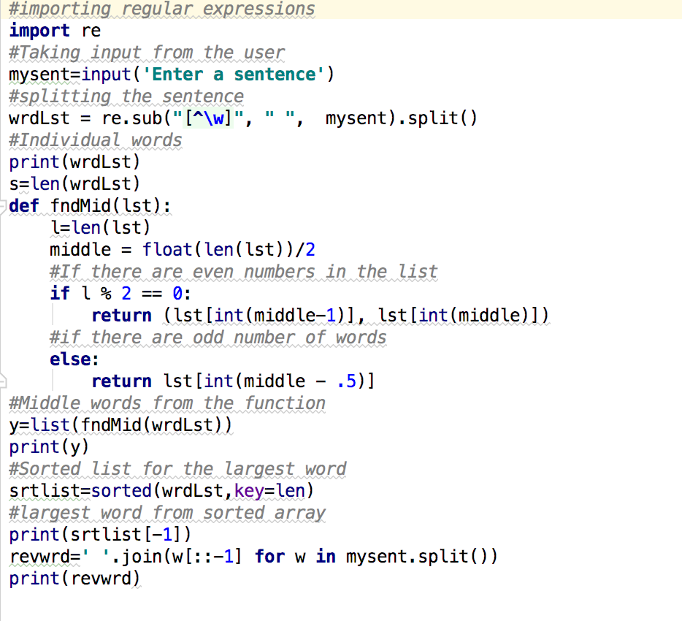

3.Triplets whose sum are Equal to Zero

This is done using the multiple iterative loops

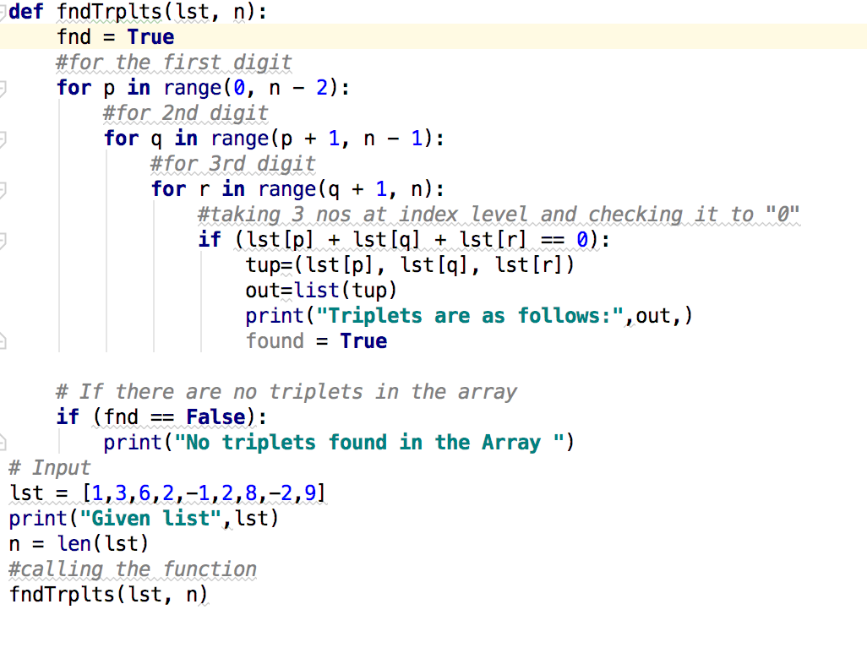

4.Students Classification:

This is done using the lists and sets operations to perform the common and other numbers.

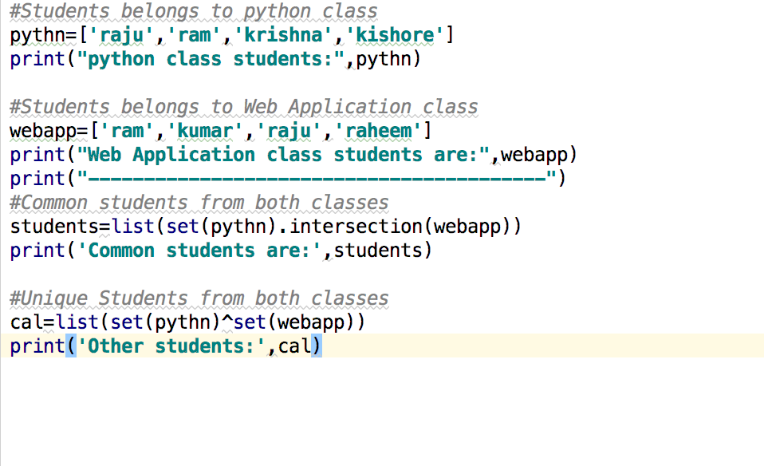

**Limitation:**

1.The above programs will be delivering the output ideally but if we give any abnormal inputs to the system then there is a chance of unexpected outputs or errors

2.These programs are tested for the given conditions in the task and shown the results as expected.

**References:**

[1] <https://stackoverflow.com/questions/41117733/validation-a-password-python>

[2] <https://stackoverflow.com/questions/32833575/how-to-find-the-longest-word-in-python>

[3] <https://www.geeksforgeeks.org/python-reverse-word-sentence/>

[4] <https://www.geeksforgeeks.org/find-triplets-array-whose-sum-equal-zero/>

[5] https://stackoverflow.com/questions/2864842/common-elements-comparison-between-2-lists